IMPROVEMENT CHARTER


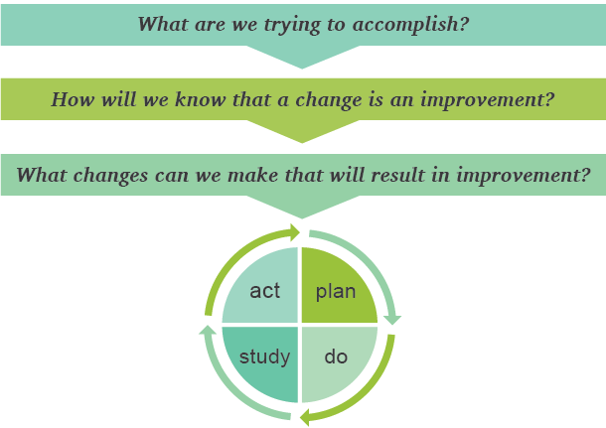
PROJECT NAME:
SPONSOR:
TEAM LEADER:
TEAM MEMBERS:
DATE:

WHAT ARE WE TRYING TO ACCOMPLISH?
Problem Statement:
Aim Statement:

Scope and Boundaries:

HOW WILL WE KNOW A CHANGE IS AN IMPROVEMENT?
 | Current Performance | Goal (prediction) | Plan to collect data for this measure:
Outcome Measures:
Process Measures:
Balancing Measures:
WHAT CHANGES CAN WE MAKE THAT WILL RESULT IN IMPROVEMENT?
Initial Change Ideas to Test:

Initial PDSA cycles: (To learn if…)

HOW WILL WE MANAGE THE IMPROVEMENT PROJECT?
Roles and Responsibilities of Team Members:
Name: | Role/Responsibilities:
Key Dates :
Plan to Incorporate Voice of Patient/Client:

